**Лабораторная работа 13 (2 часа)**

**Конструирование программного обеспечения**

**Вариант 13**

func(□)+ (begin;(□) * (abs()|□+ (x+ ));)* □ + end;- регулярное выражение

|  |  |  |  |  |  |  |
| --- | --- | --- | --- | --- | --- | --- |
| Func() | □ | begin | ; | abs | x | end |
| a | b | c | d | e | f | g |

Примеры цепочек:

1) func(□)begin; abs(); □ end; abcdedbgd

2) func(□)begin; □ abs(); □ end; abcdbedbgd

3) func(□) begin; □ end; abcdbgd

4) func(□) func(□) begin;□ (□ (x)); □ end; ababcdbbfdbgd

5) func(□)begin; □ abs(); □ □ end; abcdbedbbgd

6) func(□) begin; ( □ □ (x )); □ end; abcdbbfdbgd

7) func(□) begin; □ (□ (x x)); □ end; abcdbbffdbgd

|  |  |  |  |  |  |  |  |  |
| --- | --- | --- | --- | --- | --- | --- | --- | --- |
|  | a | b | c | d | e | f | g | λ |
| S0 | S1 | S1 |  |  |  |  |  |  |
| S1 | S1 | S2 | S2 | S2 |  |  |  |  |
| S2 |  | S3 |  | S3 | S3 | S3 |  |  |
| S3 |  | S3 |  |  |  | S3 | Sf | S4 |
| S4 |  | S4 |  |  |  |  | Sf |  |
| Sf |  |  |  |  |  |  |  |  |

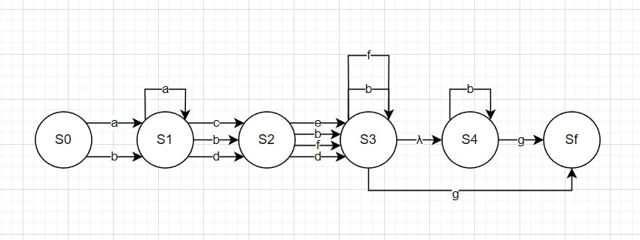

Abcdedbg

